10.04.2025
Europe and Gold !
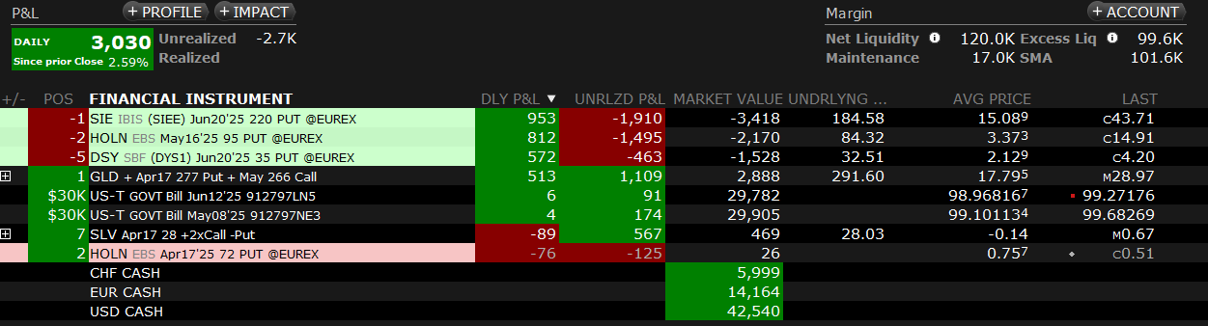
09.04.2025
SLV gains back from steep decline
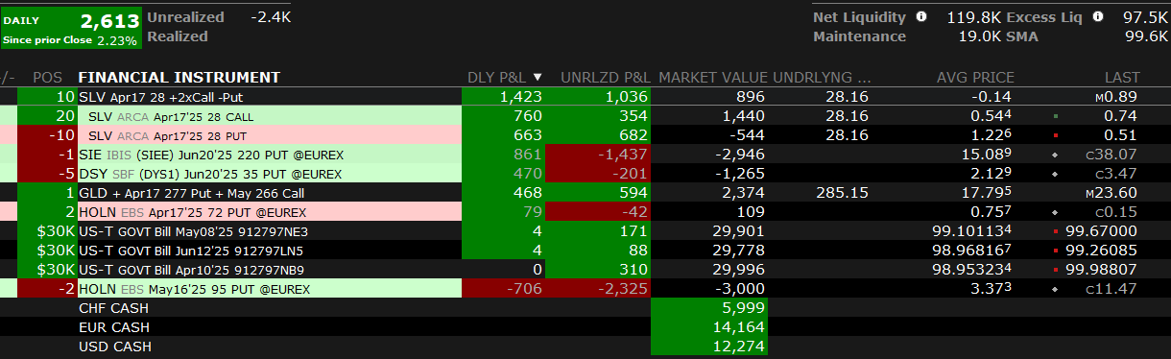

01.11.2024
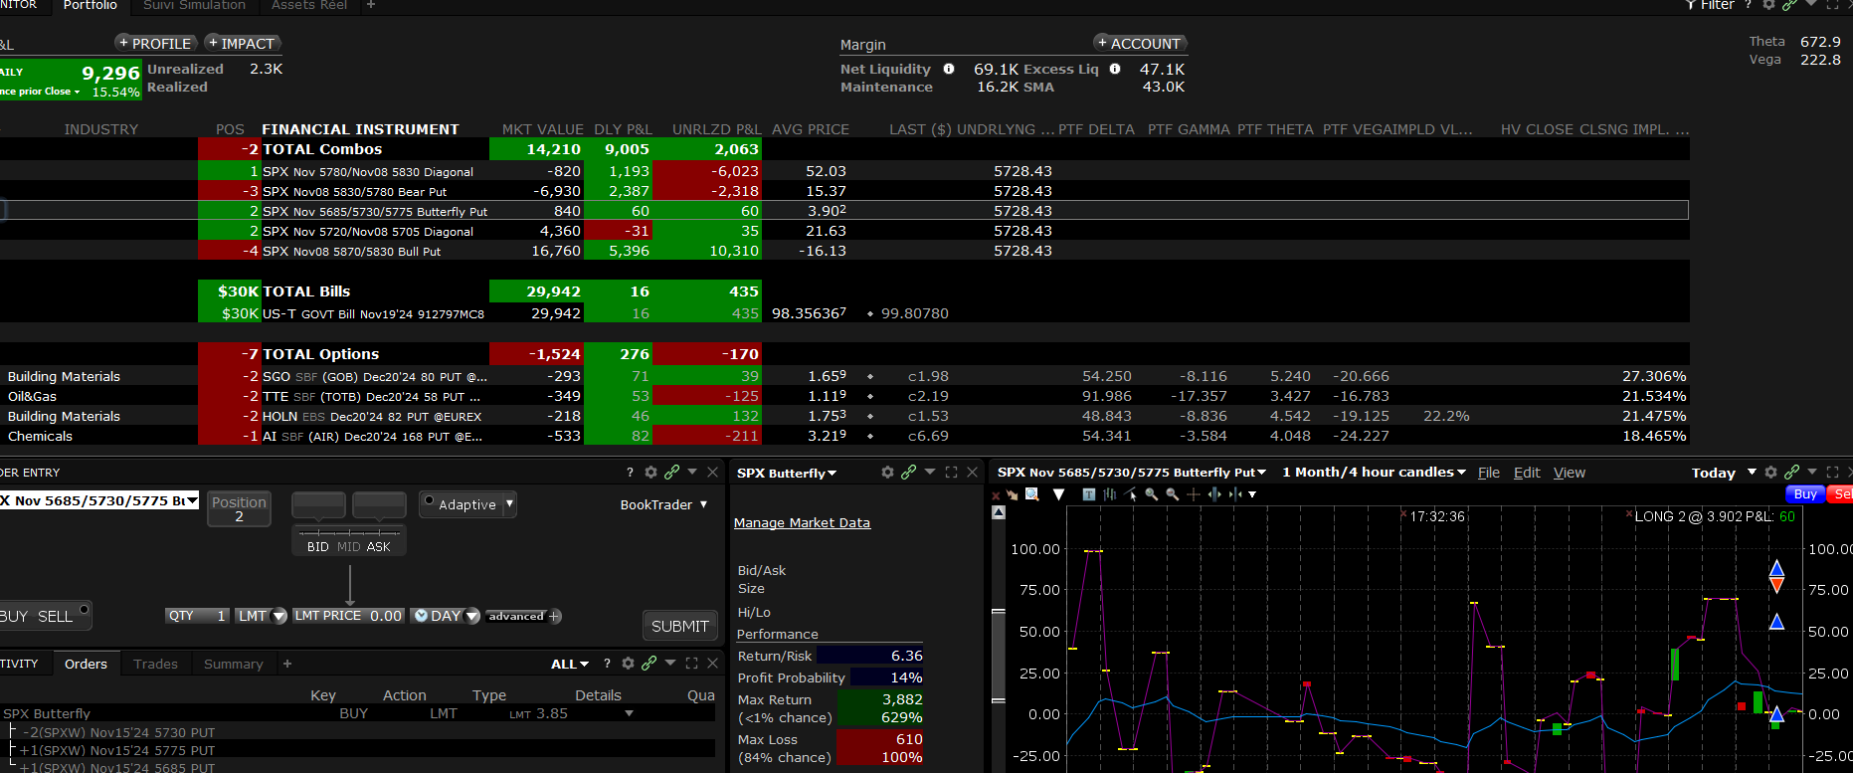
28.10.2024
A14 trades gain their previous days losses – SPX unchanged
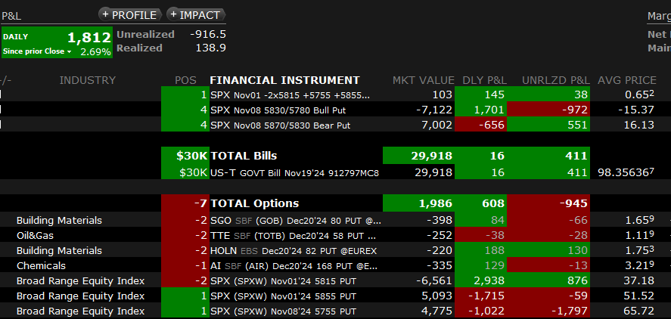

03.01.2024
ESTX50 lose 64 pts (1.4%) + vol on ESTX50 increases a bit and I am long Vega
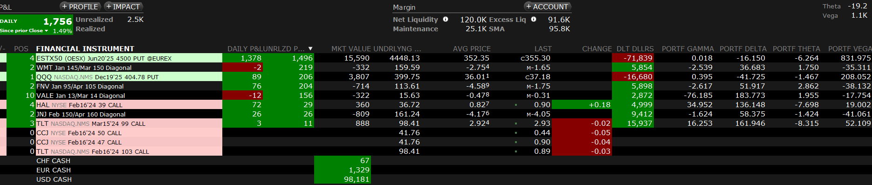
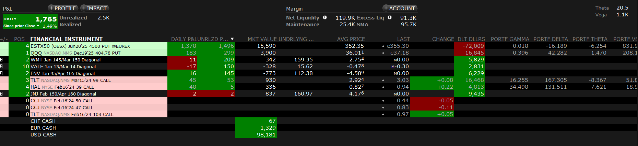

26.09.2023
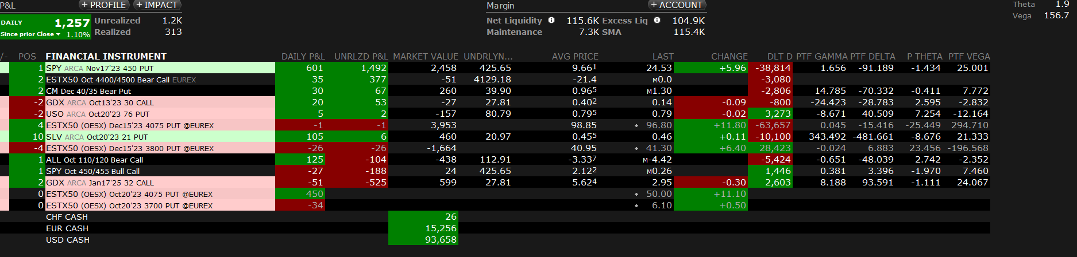
21.09.2023 Day after FOMC
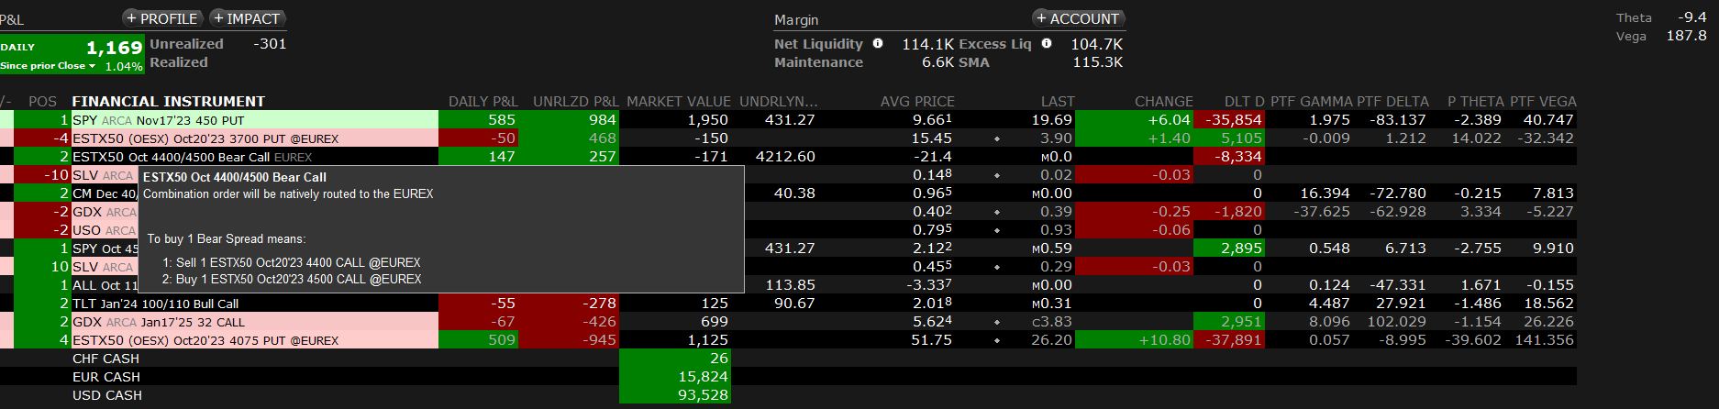
17.08.2023 Day after FOMC
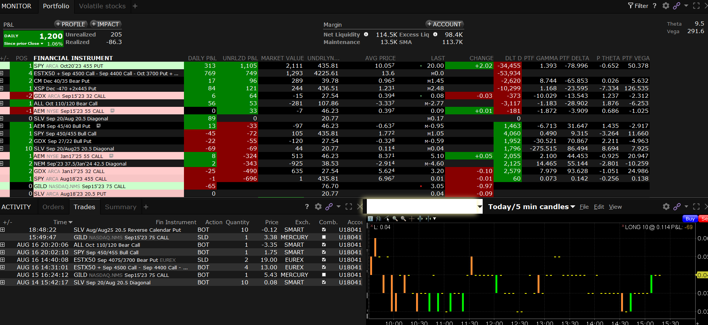
15.12.2022
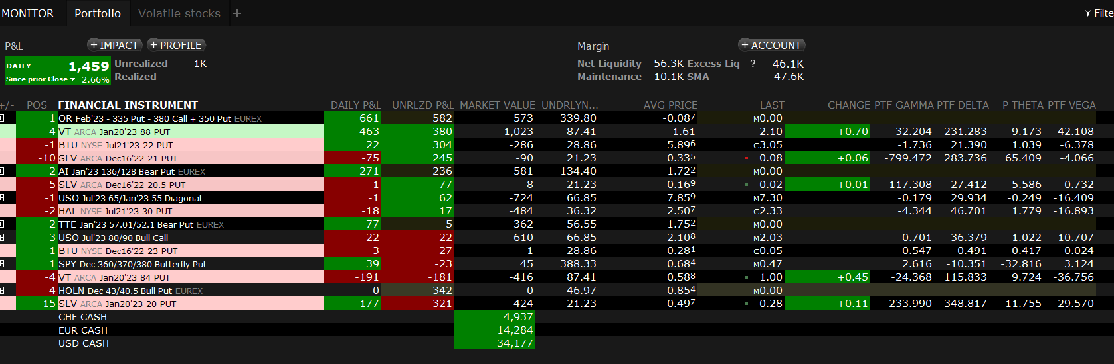

21.10.2022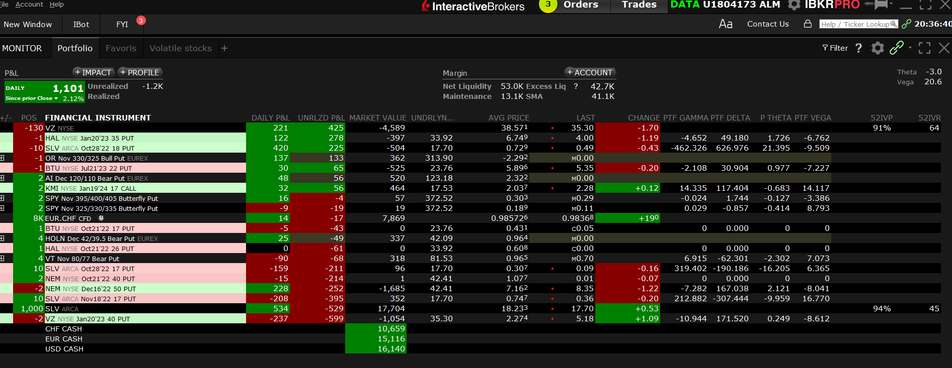
4.11.2022
Day just after FOMC Powell
